ANNEX 1

Assembly Parliamentary Service: Annual Equality Report 2006-07

1. Background
1.1 This report summarises the Assembly Parliamentary Service’s progress made in achieving positive equality outcomes between April 2006 and March 2007 with respect to its statutory equality duties on race and disability and other equality areas.

1.2 From 1 May 2007, the Government of Wales Act 2006 made for distinct reporting arrangements between the Welsh Assembly Government and the Assembly Commission. This report also summarises the positive equality outcomes that the Assembly Commission as a new body has achieved since 1 April 2007 and provides an update on future plans.

2. Overview of Progress in Mainstreaming Equality: April 2006 – March 2007

Production and Implementation of a Disability Equality Scheme and Action Plan
2.1 The production of a Disability Equality Scheme and Action Plan was the priority objective for 2006 and was approved in December 2006. An update on progress in achieving equal outcomes for disabled people can be viewed in Annex 3 as part of the Disability Equality Action Plan update. Examples of positive outcomes include: the increase in the number of staff using Voice Recognition technology to enable them to carry out their jobs safely and effectively; the assessment of the Senedd Access Audit Report and suggestions made by disabled visitors have been taken to the Senedd’s architects to discuss how access adjustments can be taken forward; and the recent Job Centre Plus ‘Positive about Disability’ award to the Assembly Commission in its capacity as an employer.

Equalities Steering Group
2.2 The Equalities Steering Group met three times and was chaired by the previous Clerk to the Assembly. The Group is still operative and consists of designated ‘equality leads’ from service areas across the organisation and contributes to the development of equality-related schemes and policies. The Chief Executive and Clerk now chairs the Group.

Stonewall Diversity Champions’ Network



2.3 The Assembly Parliamentary Service became a member of Stonewall’s Diversity Champions’ Network for Employers - a good practice forum for sexual orientation issues in the workplace. Stonewall is Britain’s leading gay equality organisation, and we are working with them and other members of the programme to improve the working environment for our lesbian, gay, bisexual and transgendered (LGBT) staff.

2.4 Employers can share information as to how they can support and empower their staff. Also, there are the opportunities to attend tailor-made programmes giving LGBT staff the opportunity to realise their own potential, challenge their own preconceptions and enable them to learn from the perspectives of other participants.

Black and Minority Ethnic (BME) Recruitment and Outreach
2.5 The BME recruitment monitoring data for the staff of the Assembly Parliamentary Service (April 2006 – March 2007) and Assembly Commission (April 2007 to current) is below:

Breakdown of Employees (as of 31 March 2007)
Number of employees | 276
No. that have declared their ethnic background | 252
No. of people from BME groups | 11 (4%)
Current Breakdown of Employees (as of 1 November 2007)
Current number of employees | 285
No. that have declared their ethnic background | 262
No. of people from BME groups | 13 (5%)
External Applications*
Total number of applicants (that have declared their ethnic background) in current year (from 1 April 2007) | 200
No. of applications from BME groups (from 1 April 2007) | 21 (10%)
Total number of applicants (that declared their ethnic background) in last financial year (April 2006 - March 2007) | 210
No. of applications from BME groups in last financial year (April 2006 - March 2007) | 18 (8%)
Appointments
No. of external appointments in current year (from 1 April 2007) | 21
No. appointments from BME groups (from 1 April 2007) | 2 (10%)
No. external appointments in last financial year (April 2006 – March 2007) | 33
No. appointments from BME groups (April 2006 - March 2007) | 1 (3%)

*Please note: many applicants fail to submit our equal opportunities monitoring form at application stage.

2.6 The following initiatives to increase BME outreach and recruitment are either underway or planned:

- A six-month paid secondment has been organised for January 2008 from the Minority Ethnic Women’s Network (MEWN). Included within the duties will be a requirement for this secondee to recommend how we improve our links with the BME communities. We also intend discussing our recruitment procedures with MEWN;

- We also intend discussing our recruitment procedures with MEWN, with other employers with high employment rates for people from BME communities and undertaking an external review of our processes from an equalities perspective;

- A series of two week work placements for people from ethnic communities will commence in 2008 alongside the above secondment;

- We have established links with Fitzalan High School to encourage pupils from BME backgrounds to undertake work placements at the National Assembly, which have already commenced; and

- External posts are advertised at Cardiff South Enterprise Centre whose customer base is largely made up of people from the BME community. We have also organised tours and briefings to coincide with any large recruitment schemes to encourage applications.

Internet Project – Disability Discrimination Act (DDA) Compliance and Accessibility
2.7 The new contract awarded for our Internet site ensured that DDA compliance and accessibility considerations were paramount. There are ongoing technical adjustments being made to ensure that our published material is accessible and DDA compliant.

Disabled Staff Network
2.8 We attempted to establish a disabled staff network to contribute to policies that could affect staff and services with the aim of improving the working environment within the organisation. Volunteers, including members of staff with disabilities or caring responsibilities, staff who have disabled friends or relatives or staff who are simply supportive and interested in promoting equality were sought to join the network. There was however, a lack of take up amongst staff for the group. We acknowledge that there might be reasons for this, including the fact that some staff might not wish to disclose a disability or do not consider themselves to have a disability.

2.9 We will look at new ways in which to encourage disabled staff and indeed disabled Assembly Members and their staff to participate in a network via disability awareness-raising. We may be able to learn from our newly established Lesbian, Gay, Bisexual and Transgendered (LGBT) network on best approaches to establishing and supporting an informal network and/or using focus groups for specific issues.

3. Overview of Progress since March 2007

Establishment of an Equalities Team within the Corporate Unit
3.1 The Corporate Unit was established in May 2007 and the Equalities Manager is building up capacity to deal with equalities-related issues across the organisation. The Equalities and Access Adviser role has also been absorbed into the Corporate Unit. The Adviser can provide a source of advice to staff and Members on access issues and other equality-related issues.

Operation Blackvote
3.2 The Operation Blackvote Scheme was launched in the Senedd by the Presiding Officer on 10 October 2007. The Scheme involves nine BME people from all over Wales shadowing Assembly Members from the four main parties. The Scheme, aimed at encouraging people from BME communities to participate in the democratic process and increasing the number of BME Assembly Members, follows on from successful MP, Magistrate and Councillor shadowing schemes.
3.3 The participants, who come from a wide range of BME communities, will shadow Assembly Members for a minimum of eight days over a six-month period in order to gain experience of life as an Assembly Member, and to help Assembly Members understand the needs of their BME constituents. They will also become community ambassadors, promoting democratic engagement within their areas.
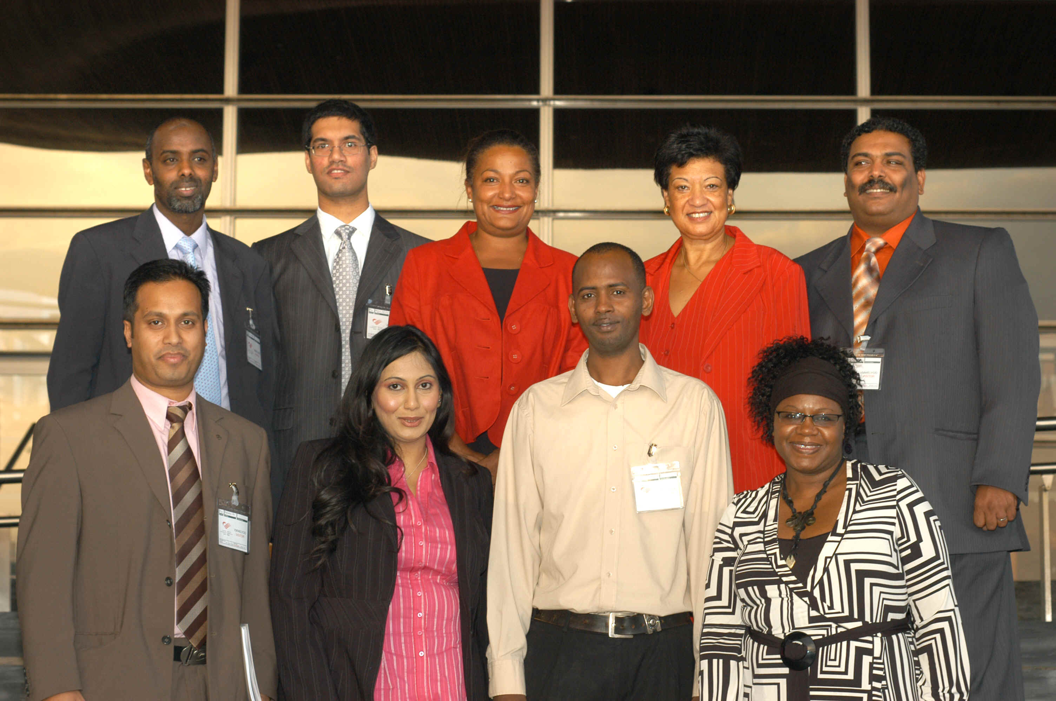

The nine OBV participants who will be shadowing Assembly Members over the next six months

3.4 The Scheme has recently been nominated for the Hansard Democracy Award, a category in Channel 4’s Annual Political Awards. This particular award is given to organisations that advance the understanding of parliamentary democracy. The outcome will be announced in January 2008.

Access Adjustments in the Senedd
3.5 To ensure that we continue to provide a high level of accessibility to the Senedd, the original Senedd Access Report has been re-examined and we have taken into account feedback from disabled members of the public who have visited the Senedd. This work suggests that we need to make some adjustments in three broad areas:-
- Better definition on terracing and public areas around the Senedd;
- Some extra manifestation to glass within the building; and
- Clearer signage which is more accessible for people with visual impairments.
3.6 We have approached the building’s architects to assist us with this work so that we are able to find the best balance between the integrity of the design and ease of access.
‘Positive about Disability’

3.7 The Assembly Commission has been awarded the ‘Positive about Disability’ Symbol by Job Centre Plus. The symbol demonstrates that we are positive about employing and retaining disabled people and that we have agreed to follow five commitments regarding their employment, retention, training and career development. Employers who use the symbol have agreed with Jobcentre Plus that they will take action on these five commitments:
- to interview all disabled applicants who meet the minimum criteria for a job vacancy and consider them on their abilities;
- to ensure there is a mechanism in place to discuss, at any time, but at least once a year, with disabled employees what can be done to make sure they can develop and use their abilities;
- to make every effort when employees become disabled to make sure they stay in employment;
- to take action to ensure that all employees develop the appropriate level of disability awareness needed to make these commitments work; and
- each year to review the five commitments and what has been achieved, plan ways to improve on them and let employees and Jobcentre Plus know about progress and future plans.
3.8 We aim to achieve a more diverse workforce and by using the symbol on job adverts and applications forms, we can demonstrate that we welcome applications from disabled people and are positive about their abilities. We hope it demonstrates to existing employees that their contributions are valued and they are treated fairly should they become disabled.

Age Positive


3.9 The Assembly Commission has recently been recognised by the Age Positive Campaign as an organisation that has demonstrated its commitment to tackling age discrimination and promoting age diversity in the workplace. The Assembly Commission now has Age Employer Champion status. Gaining Age Employer Champion status demonstrates our commitment to ensure that we do not have any discriminatory practices regarding age through our recruitment and/ or retention of employees. The accreditation panel also considered the way we offered training to our staff regardless of their age and how we offer further employment options regardless of the fact staff have reached their retirement age of 65.

Development of an informal Lesbian, Gay, Bisexual and Transgendered (LGBT) staff network
3.10 This year an informal lesbian, gay, bisexual and transgendered staff network was established by ‘out’ gay members of staff. The network is primarily a social network but has agreed to contribute to the development of policies, schemes and other equality-related issues through impact assessing our draft policies. Since an article regarding the network was placed in the staff newsletter, ‘The Slate’ in October, more members of staff have joined the network.

Stonewall’s Recruitment ‘Starting Out’ Guide and Workplace Equality Index
3.11 The Assembly Commission has been included in Stonewall’s ‘Starting Out - Lesbian and Gay Recruitment Guide’ 2007-08. The Guide is aimed at students and those wishing to change their careers, to advise them of gay-friendly employers.

3.12 The Assembly Commission has also made a submission for inclusion in Stonewall’s Workplace Equality Index 2008 – the guide to the top 100 UK gay-friendly employers. We are awaiting the results of our submission.

Awareness-raising of equalities-related issues amongst staff
3.13 Between April 2006 and March 2007, four equalities-related articles were placed on the intranet newspage and the staff newsletter, ‘The Slate’. From 1 April 2007 onwards, there have been four equalities-related articles. Topics on which articles have focussed have included the Disability and Gender Equality Duties, International Women’s Day, Stonewall Diversity Champions’ Network and Operation Blackvote.

Draft Gender Equality Scheme
3.14 A draft Gender Equality Scheme was prepared over the summer of 2007 and impact assessments were carried out on existing work practices. A number of actions/desired outcomes have been identified and this work will be subsumed into the production of a Single Equalities Scheme and Action Plan for 2008 (see below).

3.15 In 2008, the Assembly Commission will sponsor the ‘Woman Advancing Democracy Category’ in the Welsh Woman of the Year Awards. The Awards promote the role women have in the workplace and in every sector of society, raise awareness and reflect and reinforce the changing role of women over the last 14 years by celebrating their achievement and the value of their contributions to the stability of Wales.

4. Future Plans

Developing a Single Equalities Scheme and Action Plan
4.1 The Assembly Commission will be developing a Single Equalities Scheme and Action Plan for publication next year. The Scheme will cover the following equality strands: age, disability, faith/belief, gender/gender identity, race and sexual orientation. We aim to involve individuals and organisations at an early stage in the development of the Scheme and will consult widely in the New Year. The Equality of Opportunity Committee is invited to consider the Draft Scheme and Action Plan in early 2008 as part of this process.

Monitoring Staff Data/Workforce Profiling
4.2 The Assembly Commission recognises that in order to identify and inform our equalities objectives, we need to have robust mechanisms for gathering and monitoring equalities data in order to profile our workforce. The development of our HR IT information management system, specifically the roll-out of a ‘U-Access’ (self-service) module, will enable staff to enter and amend their own personal details on the system, which will include information relating to ethnicity, disability and sexual orientation. The information will be stored securely and will be confidential but will provide a generic profile of our workforce. This module will be rolled-out early in 2008.

Impact Assessment Tool
4.3 Alongside the development of the Single Equalities Scheme and Action Plan, the Equalities Team is developing an enhanced impact assessment tool. A programme of training to accompany the new tool will be available for relevant staff to access.

Awareness-Raising for Members on Equalities Issues
4.4 By the end of this year, Members will be provided with a research paper to clarify the new arrangements for equality in relation to the statutory responsibilities of the Assembly Commission and Welsh Ministers respectively. This is for information and will help to raise awareness of equalities issues amongst Members and their staff. The research paper will be a precursor to further awareness-raising activities which are detailed below.

Awareness-Raising Activities/Events
4.5 The Equalities Team will consider imaginative ways in which we can raise awareness amongst staff, Members, Members’ support staff and those who interact with our organisation. Activities such as focus groups, information stands in the Assembly buildings, use of the staff newsletter and articles on the intranet/internet pages could contribute to raising awareness.

Developing Targeted Training for Staff
4.6 As well as the need to raise awareness about how equality issues relates to our daily jobs in our workplace, there is a role for specific training to be offered to staff across the workplace. Staff who design policies and strategies need to be trained to undertake equality impact assessments. Also, staff in service areas such as Research (briefing Members), IT (accessible website) and Human Resources (employment policies) might identify opportunities to build in equalities considerations to their work. The Equalities Team and Human Resources Team will work with service areas to assist them in identifying their own equalities-related training requirements.

Corporate Unit
November 2007

